**NOISE POLLUTION MONITORING PHASE_5**

**ABSTRACT:**

In urban, noise pollution is a prevalent issue, affecting public health and well-being. Existing noise monitoring systems are often limited in scope, accessibility, and real-time capabilities, hindering informed decision-making and public awareness. To address this problem, our project aims to design and implement an integrated IoT-based Noise Pollution Monitoring system that accurately measures noise levels in public spaces, provides real-time data accessible through a user-friendly platform and mobile app, and leverages data analytics to identify noise pollution patterns. By doing so, we seek to raise public awareness, promote noise regulation compliance, and contribute to the improvement of overall quality of life in urban environments.

Our solution is to enhance an IoT-based Noise Pollution Monitoring system that integrates hardware (IoT sensors), software (a web-based platform and a mobile app), and data analytics to measure, visualize, and analyze noise pollution in real-time. This solution will raise public awareness, facilitate regulatory compliance, and contribute to noise pollution mitigation



**COMPONENTS REQUIRED**:

• Bluetooth HC 05

• Sound sensor module

• Wires

• Vibration motor/ Buzzer

• Arduino Nano

**FEATURES OF COMPONENTS:**

**1. Vibration Motor/Buzzer:**

This component can be used to generate alerts or notifications in response to certain noise levels detected by the sound sensor module. It's a tactile or auditory feedback mechanism to inform users about noise events.

**2.Bluetooth HC-05:**

The Bluetooth module can be used for wireless communication between your Arduino Nano. It enables data transmission, which can include noise level readings or alerts.

**3. Sound Sensor Module:**

The sound sensor module is a critical component for measuring noise levels. It detects sound and converts it into electrical signals that can be processed by the Arduino Nano. The data from this sensor forms the basis of your noise pollution monitoring system.

**4. Wires**

Wires are essential for connecting and establishing electrical connections between various components in your project. They ensure data and power transfer between the Arduino, sound sensor, and Bluetooth module.

**5. Arduino Nano:**

The Arduino Nano serves as the central controller for your project. It processes data from the sound sensor, triggers the vibration motor or buzzer for alerts, and communicates with the Bluetooth module for data transmission or interaction with other devices.

**PROGRAM:**

#include <SoftwareSerial.h>

const int soundSensorPin = A0;

const int vibrationMotorPin = 8;

SoftwareSerial BTSerial(10, 11);

void setup() {

pinMode(soundSensorPin, INPUT);

pinMode(vibrationMotorPin, OUTPUT);

Serial.begin(9600);

BTSerial.begin(9600);

}

void loop() {

int soundValue = analogRead(soundSensorPin);

int threshold = 500;

// If the sound level exceeds the threshold, trigger the motor and send data via Bluetooth

if (soundValue > threshold) {

digitalWrite(vibrationMotorPin, HIGH);

BTSerial.print("Noise Level: ");

BTSerial.println(soundValue);

delay(1000); // Vibration motor runs for 1 second

digitalWrite(vibrationMotorPin, LOW);

}

while (BTSerial.available()) {

char c = BTSerial.read();

  }

}

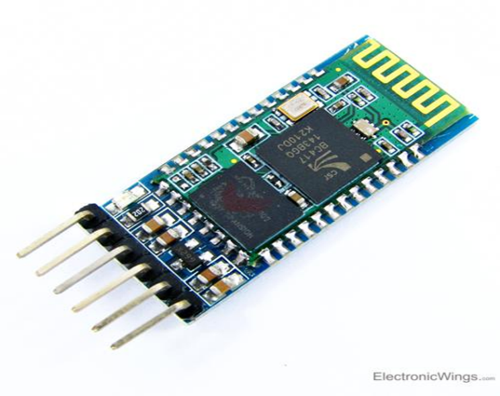 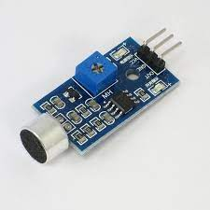

**Bluetooth HC 05 Sound sensor**

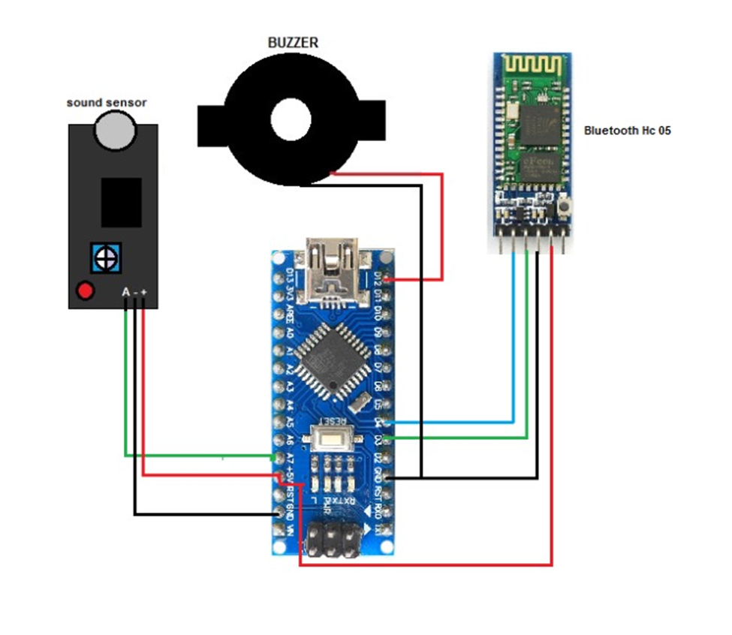

**Connection diagram**

**APP MAKING:**

We are going to use the MIT app inventor for creating our app. In the first part, we need to create a layout and add the following components

**•** A list picker

• A textlevel

• 2 button

**•** 1 text view

• Sound recorder

• Tiny DB

• Bluetooth client

**CONNECTION:**

**Arduino Nano Components**

**•** Pin A7 - Sound Sensor Out

• 5v - VCC Bluetooth & Sound sensor

• GND - GND Bluetooth & Sound senor

• D4 - RX

• D3 - TX

• D12 - Buzzer VCC

• GND - Buzzer GND

**TESTING:**

For testing we need to power the Arduino and connect the Bluetooth with the app. After making connection, we can test it by making loud noises. When the sound level crosses the threshold value, the Noise Detector device will buzz to notify about it and at the same time the app will start recording the sound and it will go on recording until the level comes down below the threshold level

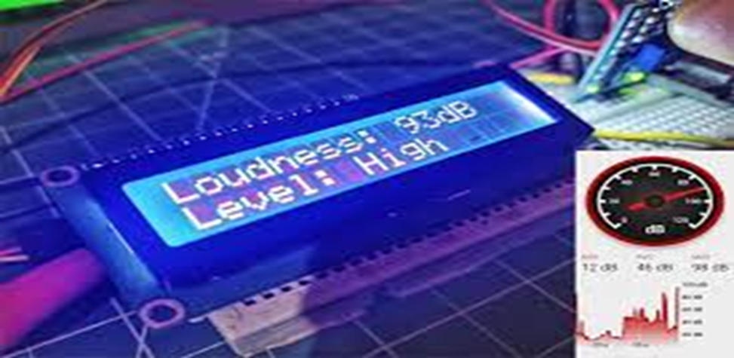

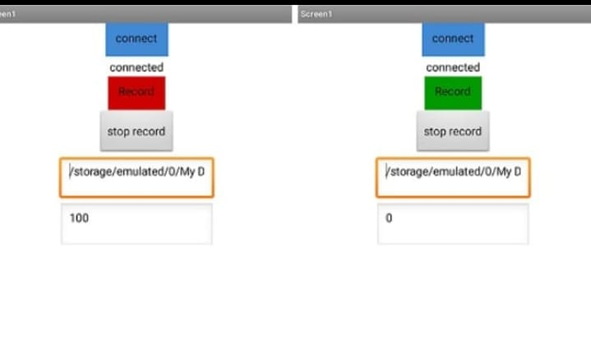

**CONCLUSION:**

Ultimately, the project seeks to enhance the overall quality of life in urban environments by reducing the adverse effects of noise pollution. The project has the potential to make a significant and positive impact on the communities it serves, contributing to quieter and healthier urban living environments**.**